Profile of the

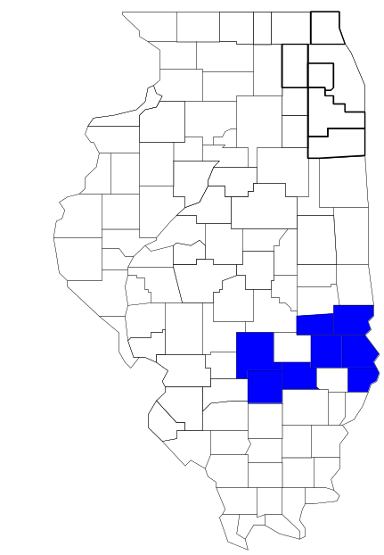Southeastern Illinois Drug Task Force

Prepared by

The Research and Analysis Unit of the
Illinois Criminal Justice Information Authority

George H. Ryan, Governor
Peter B. Bensinger, Chairman
Candice M. Kane, Executive Director

March 2001



ILLINOIS
CRIMINAL JUSTICE
INFORMATION AUTHORITY

This project was supported by Grant # 99-DB-BX-0017, awarded to the Illinois Criminal Justice Information Authority by the Bureau of Justice Assistance, Office of Justice Programs, U.S. Department of Justice. The Assistant Attorney General, Office of Justice Programs, coordinates the activities of the following programs, offices and bureaus: Bureau of Justice Assistance, Bureau of Justice Statistics, National Institute of Justice, Office of Juvenile Justice and Delinquency Prevention, and the Office for Victims of Crime. Points of view or opinions contained within this document are those of the authors and do not necessarily represent the official position or policies of the U.S. Department of Justice.

Illinois Criminal Justice Information Authority
120 S. Riverside Plaza, Suite 1016
Chicago, Illinois 60606-3997
Telephone (312) 793-8550
Telefax (312) 793-8422
TDD: (312) 793-4170
World Wide Website http://www.icjia.state.il.us
ACKNOWLEDGMENTS

A number of organizations and individuals put a great deal of effort into the development of this document. The Authority’s Research and Analysis Unit is very grateful for the assistance provided by the following organizations:

Administrative Office of the Illinois Courts
Illinois Department of Human Services’ Office of Alcoholism and Substance Abuse
Illinois Department of Children and Family Services
Illinois Department of Corrections
Illinois State Police
Southeastern Illinois Drug Task Force
U.S. Bureau of the Census

In addition, the following individuals were instrumental in gathering, interpreting and presenting these data:

Sharyn Adams

Megan Alderden

Robert Bauer

Alissa Clark

John Condne

Karen Griffiths

Tracy Hahn

Jennifer Hiselman

David Katz

Joseph Kozenczak

Gary Kupsak

Erica Morrow

David Olson

Adrianna Perez

Gerard Ramker

Robert Taylor

CONTENTS

Section Page Number

I. Introduction 1
II. Trends in Violent Index Offenses and Arrests 3
III. Trends in Drug Arrests 6
IV. Trends in Drug Seizures 15
V. Trends in Prosecutions for Drug Offenses 17
VI. Trends in Percent of Convicted Drug Offenders Sentenced to Prison 19
VII. Trends in Drug Treatment Admissions in SEIDTF Region by Drug Type 24
VIII. Trends in Drug Exposed Births 27
IX. Summary of Drug Situation 28
X. Appendices 30
Map 1 1999 Percent of Illinois' County-level Population Covered by an
Authority-funded Multi-jurisdictional Enforcement Group or Task Force 31
Map 2 1999 Illinois Cannabis Seizure Rates, by County 32
Map 3 1999 Illinois Controlled Substances Seizure Rates, by County 33
Map 4 1999 Illinois Methamphetamine Seizure Rates, by County 34
XI. Bibliography 35

LIST OF FIGURES

Figure Page Number Page Number

Figure 1. Violent Index Offense Rates for Participating and Non-participating Agencies in Region Covered by SEIDTF 3
Figure 2. 1999 Violent Index Offenses* Reported by Participating and Non-participating Agencies in Region Covered by SEIDTF 4
Figure 3. Violent Index Arrest Rates for Participating and Non-participating Agencies in Region Covered by SEIDTF 5
Figure 4. 1999 Violent Index Arrests* Reported by Participating and Non-participating Agencies in Region Covered by SEIDTF 5
Figure 5. Total Drug Arrest Rates for SEIDTF and Participating and Non-participating Agencies in Region Covered by SEIDTF 7
Figure 6. 1999 Drug Arrests* Reported by Participating and Non-participating Agencies in Region Covered by SEIDTF 8
Figure 7. Total 1999 Drug Arrests* Reported by Participating and Non-participating Agencies in Region Covered by SEIDTF, by Drug Type 8
Figure 8. Drug Arrests by SEIDTF 9
Figure 9. Percent of Total Drug Arrests Accounted for by SEIDTF 10
Figure 10. Cannabis Arrests Rates in the Region Covered by SEIDTF as Reported by Participating Agencies, Non-participating Agencies and SEIDTF 11
Figure 11. Percent of Cannabis Arrests Accounted for by SEIDTF
12
Figure 12. Controlled Substances Arrest Rates in the Region Covered by SEIDTF as Reported by Participating Agencies, Non-participating Agencies and SEIDTF 13
Figure 13. Percent of Controlled Substances Arrests Accounted for by SEIDTF 13
Figure 14. SEIDTF Drug Arrests for Possession versus Delivery, by Drug Type 14
Figure 15. Cannabis Seized and Submitted to ISP by Clark, Clay, Crawford, Cumberland, Fayette, Jasper, Lawrence and Marion Counties and Seized by SEIDTF 15
Figure 16. Powder and Crack Cocaine Seized and Submitted to ISP by Clark, Clay, Crawford, Cumberland, Fayette, Jasper, Lawrence and Marion Counties and Seized by SEIDTF 16
Figure 17. Number of Felony Filings in Clark, Clay, Crawford, Cumberland, Fayette, Jasper, Lawrence and Marion Counties 17
Figure 18. Total SEIDTF Drug Arrests and Percentage of Arrests Resulting in Felony Prosecution 18
Figure 19. Sentences Imposed on Felons Convicted in Clark, Clay, Crawford, Cumberland, Fayette, Jasper, Lawrence and Marion Counties
19
Figure 20. Sentences Imposed on Convicted SEIDTF Drug Offenders 20
Figure 21. Number of Drug Offenders Committed to IDOC by SEIDTF and Region Covered by SEIDTF 21
Figure 22. Drug Offenders as a Percent of Total IDOC Commitments from Clark, Clay, Crawford, Cumberland, Fayette, Jasper, Lawrence and Marion Counties 22
Figure 23. Drug Offenders Committed to IDOC from Clark, Clay, Crawford, Cumberland, Fayette, Jasper, Lawrence and Marion Counties, by Offense Class 23
Figure 24. Substance Abuse Treatment Admissions from Clark, Clay, Crawford, Cumberland, Fayette, Jasper, Lawrence and Marion Counties 24
Figure 25. Comparison of Drug Arrests by SEIDTF and Participating and Non-participating Agencies vs. Drug Abuse Treatment Admissions in Clark, Clay, Crawford, Cumberland, Fayette, Jasper, Lawrence and Marion Counties, 1999 26
Figure 26. Cases of Drug-Exposed Infants in Clark, Clay, Crawford, Cumberland, Fayette, Jasper, Lawrence and Marion Counties 27
Figure 27. Availability of Drugs in Illinois, 1998 28
Figure 28. Price Per Gram in Illinois, 1998 29

EXECUTIVE SUMMARY

Since 1989, the Authority’s Research and Analysis Unit has received funds under the federal Anti-Drug Abuse Act of 1988 to document the extent and nature of drug and violent crime in Illinois and the criminal justice system’s response to these offenses. As a result of these efforts, the Authority has amassed a large amount of data measuring the extent and nature of drug and violent crime in Illinois and the impact these crimes have had on the criminal justice system. In addition, as part of its monitoring and evaluation efforts, the Authority also requires funded programs to submit monthly data reports describing their activities and accomplishments. This profile is intended to provide a general overview of the drug and violent crime problem in the jurisdictions covered by Illinois’ MEGs and task forces, and the response to these problems by the units.

Although the data presented in this report are by no means inclusive of all indicators, they do provide a general overview of drug and violent crime and the response and impact of the criminal justice system. The following represent general conclusions that can be made based on the data analyzed for this report.

- In 1999, nine local Illinois police agencies participated in SEIDTF (a participating agency is defined as one that contributes either personnel or financial resources to SEIDTF). Officers assigned to SEIDTF (totaling 12 in 1999, nine from participating agencies) accounted for 12 percent of the total number of sworn police officers working for agencies participating in SEIDTF.

- The violent Index offense rate was higher across jurisdictions that did not participate in SEIDTF than among the combined jurisdictions that did participate in SEIDTF between 1995 and 1999. The rate was higher across jurisdictions that did participate in SEIDTF between 1993 and 1994 (page 3).

- The drug arrest rates for participating agencies, non-participating agencies and SEIDTF increased between 1993 and 1999. The rate achieved by non-participating agencies was consistently higher than the rate in the other two areas (page 6).

- When comparing the types of drug offenders arrested by those agencies participating in SEIDTF, those agencies not participating and SIDTF, it was found that SEIDTF tended to target and arrest more serious drug law violators, specifically violators of the Controlled Substances Act, which tend to be felony-level offenses (page 9).

- The majority of all drug arrests reported by SEIDTF, for either violations of the Cannabis Control Act or the Controlled Substances Act, involved drug sale or delivery. However, the proportion of those arrests accounted for by arrests for delivery significantly, from 88 percent in 1993 to 43 percent in 1999 (page 14).

- Between 1993 and 1999, the amount of cannabis and cocaine seized by SEIDTF decreased , while the quantity of methamphetamine seized by SEIDTF jumped from zero grams in 1995 to 921 grams in 1999 (pages 15 and 16).

- Between 1992 and 1999, the majority of all drug arrests by SEIDTF resulted in prosecution. In addition, between 1989 and 1999, 76 percent of all drug offenders who were prosecuted as a result of SEIDTF activity were convicted (page 18).
- In 1999, among those SEIDTF drug offenders convicted and sentenced, probation sentences accounted for the largest proportion (51 percent), followed by jail sentences (28 percent) and prison sentences (21 percent) (page 20).

- Between 1989 and 1999, prison sentences resulting from SEIDTF cases accounted for 40 percent of all drug-law violators sent to prison from the region where SEIDTF operates. However, the proportion of prison sentences resulting from SEIDTF cases decreased during the period analyzed, from 67 percent in 1992 to 31 percent in 1999 (page 21).

- Unlike the arrests made by the participating and non-participating agencies, the arrests made by SIDTF tended to involve substances considered to be the most serious (i.e., felony versus misdemeanor), although these substances tended not to be the reason for which a large proportion of community residents were seeking and receiving substance abuse treatment in 1999 (page 25).

I. Introduction

The Southeastern Illinois Drug Task Force (SEIDTF) covers the Illinois counties of Clark, Clay, Crawford, Cumberland, Fayette, Jasper, Lawrence and Marion. Combined, these counties had a 1999 total population of 141,800 – 2 percent more than in 1990. In 1999, nine local Illinois police agencies participated in SEIDTF. These include the following sheriff's offices: Clark County, Crawford County, Cumberland County, Fayette County, Jasper County, Lawrence County and the following municipal police departments: Flora, Palestine and Salem. These agencies served 46 percent of the population in the eight-county region covered by SEIDTF in 1999 (see Map 1 on page 31). A participating agency is defined as one that contributes either personnel or financial resources to SEIDTF.

In addition to agencies that participate in SEIDTF, these Illinois counties are served by 26 additional police departments that do not participate in SEIDTF. According to the Illinois State Police, county sheriffs and local police departments, in the eight-county region covered by SEIDTF, combined, employed 190 full-time police officers as of Oct. 31, 1999, 73 of which worked in agencies participating in SEIDTF. In comparison, there were a total of 12 officers assigned to SEIDTF in 1999, nine of which were assigned by participating agencies and three from the Illinois State Police (ISP). Thus, the officers assigned to SEIDTF during 1999 accounted for a relatively small proportion—12 percent—of the total number of sworn police officers working in the participating police departments, and the region as a whole.

In addition to administering federal block-grant funds that come to Illinois for crime control initiatives, the Illinois Criminal Justice Information Authority is also responsible for providing policymakers, criminal justice professionals and others with information, tools and technology needed to make effective decisions that improve the quality of criminal justice in Illinois The Authority provides an objective system-wide forum for identifying critical problems in criminal justice, developing coordinated and cost-effective strategies, and implementing and evaluating solutions to those problems. The specific powers and duties of the Authority are delineated in the Illinois Criminal Justice Information Act (Illinois Compiled Statutes, Ch. 20, Sec. 3930). Two of the Authority’s many responsibilities are serving as a clearinghouse of information and research on criminal justice and undertaking research studies to improve the administration of criminal justice.

Since 1989, the Authority’s Research and Analysis Unit has received funds under the federal Anti-Drug Abuse Act of 1988 to document the extent and nature of drug and violent crime in Illinois and the criminal justice system’s response to these offenses. As a result of these efforts, the Authority has amassed a large amount of data measuring the extent and nature of drug and violent crime in Illinois and the impact these crimes have had on the criminal justice system. In addition, as part of its monitoring and evaluation efforts, the Authority also requires funded programs to submit monthly data reports describing their activities and accomplishments. To put this information into the hands of Metropolitan Enforcement Group (MEG) and drug task force directors and policy board members, the Authority’s Research and Analysis Unit has developed profiles – of which this is one – for each MEG and task force. The profile is intended to provide a general overview of the drug and violent crime problem in the jurisdictions covered by Illinois’ MEGs and task forces, and the response to these problems by the units.

While the data presented in this report are by no means inclusive of all indicators, they do provide a general overview of drug and violent crime and the response and impact of the criminal justice system. In addition, these data are readily available and consistently defined through existing statewide data collection mechanisms. Some data presented in this profile have been analyzed differently than in previous years; therefore, caution must be taken when comparing numbers presented with previous profiles.

While a considerable amount of the information presented in this profile has been provided to the Authority by SEIDTF, a number of state agencies have also provided data to the Authority that are included in this report. Specifically, the Illinois State Police, the Administrative Office of the Illinois Courts, the Illinois Department of Human Services’ Office of Alcoholism and Substance Abuse, the Illinois Department of Corrections and the Illinois Department of Children and Family Services all provided data used to develop this profile. The support and cooperation of these agencies and their staffs have helped make this report an informative and timely source of information on the activities of the criminal justice system in Illinois.

- Trends in Violent Index Offenses and Arrests

While most of Illinois’ Metropolitan Enforcement Groups and drug task forces are primarily involved in drug enforcement activities, it is clear that the relationship between drugs and violence is particularly evident in a number of Illinois communities. In addition, a number of MEGs and task forces have increased their involvement in the investigation of violent crime, particularly that associated with gang activity and violence related to drug distribution, sale and turf battles. One of the most commonly used indicators of the level of crime in a particular jurisdiction is the number of Index offenses reported to the police. In Illinois, as part of the Illinois Uniform Crime Reporting (I-UCR) program, every law enforcement agency in the state is required to report crime data monthly to the Illinois State Police (ISP). There are eight separate offenses that constitute the Crime Index, including murder, criminal sexual assault, robbery, aggravated assault (violent Index offenses), burglary, theft, motor vehicle theft and arson (property Index offenses). Although these eight offenses do not account for all crimes reported to the police, they are considered to be the most serious, frequent, pervasive and consistently defined by different law enforcement agencies.

In 1999, the number of violent Index offenses reported to the police in the eight-county region covered by SEIDTF totaled 353, an 11 percent decrease from the 395 offenses reported in 1993. During the period analyzed, the violent Index offense rate for the region covered by SEIDTF decreased 12 percent, from 281 offenses per 100,000 population in 1993 to 249 offenses per 100,000 population in 1999. Similarly, the violent Index offense rate in the participating agencies decreased 45 percent, from 338 to 187 offenses per 100,000 population, while the rate in the non-participating agencies increased 29 percent, from 234 to 301 offenses per 100,000 population (Figure 1). Thus, the violent Index offense rate was higher across jurisdictions that participated in SEIDTF in 1993 and 1994, but was higher in jurisdictions that did not participate in SEIDTF between 1995 and 1999.
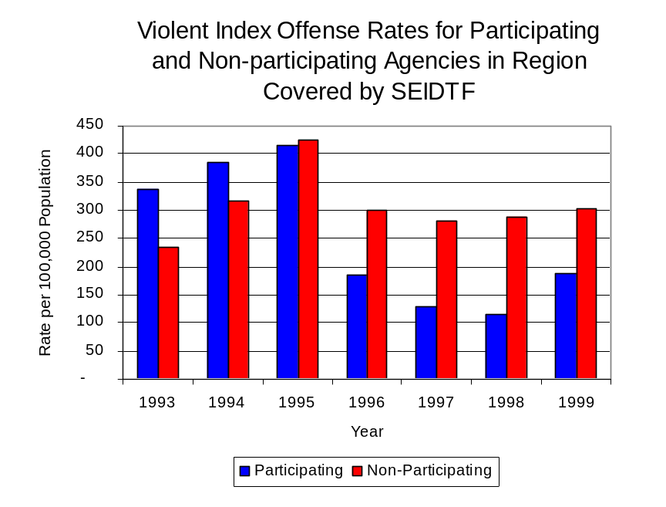
Source: ICJIA calculations using
Illinois State Police and U.S. Census Bureau data
Figure 1

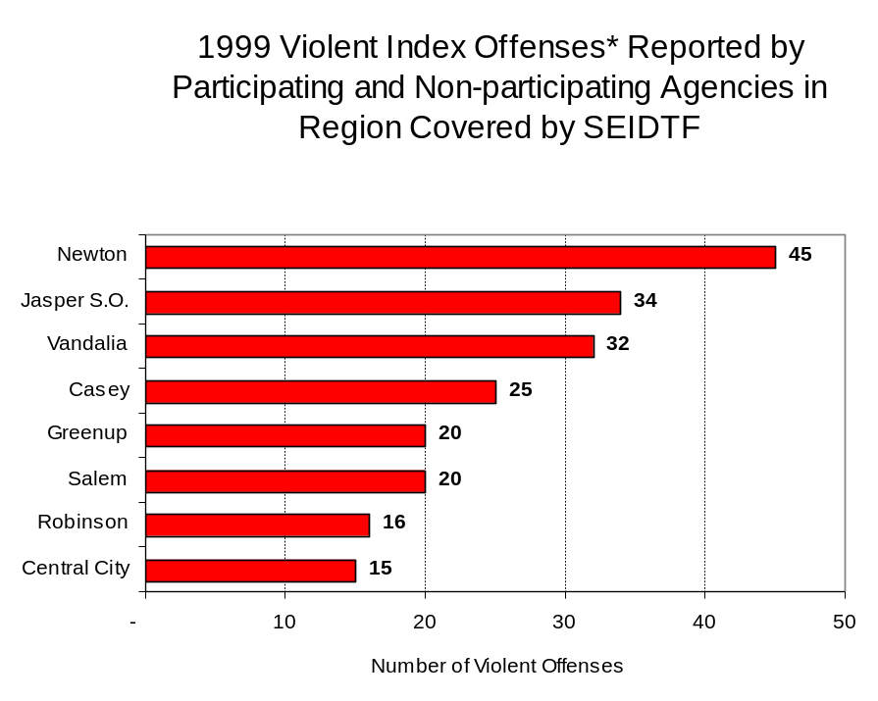
Across the 35 individual local law enforcement agencies covered by SEIDTF’s jurisdiction, eight agencies, the Newton Police Department, the Jasper County Sheriff’s Office, the Vandalia Police Department, the Casey Police Department, the Greenup Police Department, the Salem Police Department, the Robinson Police Department, and the Central City Police Department, accounted for 59 percent of all violent offenses reported to the police (Figure 2). Twenty-one agencies had fewer than 15 violent offenses reported in 1999 and are excluded from Figure 2. When controlling for differences in the populations served by these law enforcement agencies, the violent Index offense rate ranged from zero violent Index offenses per 100,000 population in Martinsville and Hutsonville to 1,385 offenses per 100,000 population in Newton.
Source: Illinois State Police *Agencies reporting 15 or more violent offenses

Figure 2
An indicator of the workload that law enforcement agencies place on other components of the justice system is the number of arrests made by police, including those for violent and property Index offenses and drug offenses. Unlike offenses, which are what police must respond to, arrests represent those offenders who may eventually be processed through other components of the justice system, including the courts, county jails, and state and local correctional programs.

Between 1993 and 1999, the number of arrests for violent Index offenses made by law enforcement agencies in the region covered by SEIDTF decreased 6 percent, from 268 to 252. As with reported violent Index offenses, the majority (89 percent) of violent Index arrests were for aggravated assaults, followed by criminal sexual assaults (9 percent).

During the period analyzed, the violent Index arrest rate for the region covered by SEIDTF decreased 7 percent, from 191 offenses per 100,000 population in 1993 to 178 arrests per 100,000 population in 1999. The violent Index arrest rate in the participating agencies decreased 43 percent, from 217 to 124 offenses per 100,000 population, while the rate in the non-participating agencies increased 32 percent, from 169 to 223 offenses per 100,000 population (Figure 3). Thus, excluding 1993, the violent Index arrest rate was higher in jurisdictions not participating in SEIDTF.

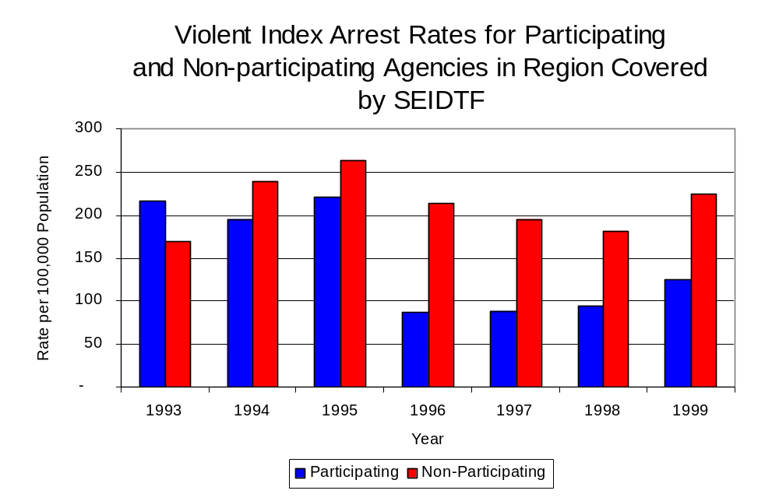
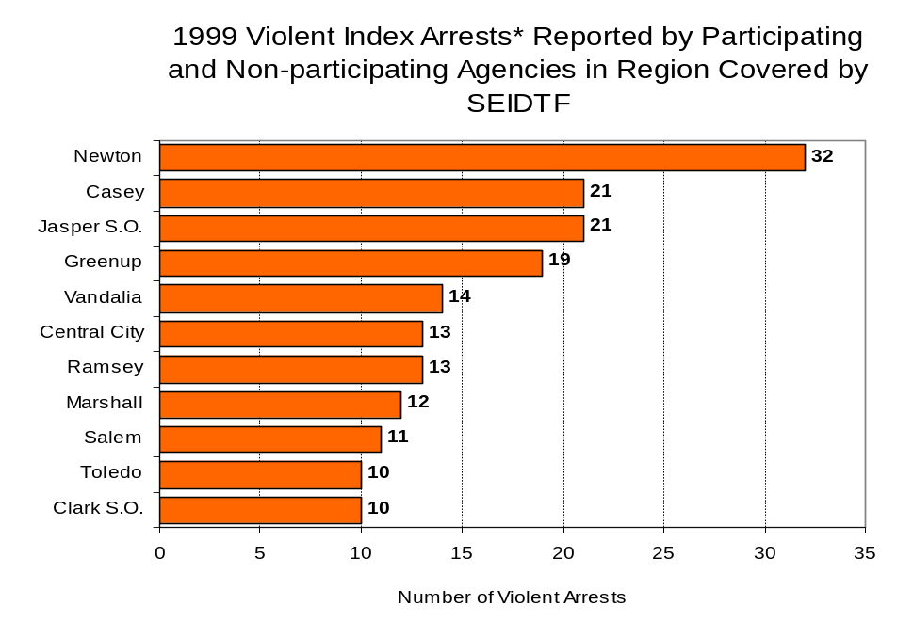
The majority (70 percent) of arrests for violent Index offenses occurring in the eight-county region covered by SEIDTF was made by 11 agencies. Twenty-four agencies had fewer than ten arrests for violent Index offenses reported in 1999 and are excluded from Figure 4. Of the 252 violent Index arrests made in 1999, the Newton Police Department accounted for the majority (13 percent), followed by the Casey Police Department, the Jasper County Sheriff’s Office and the Greenup Police Department, each accounting for 8 percent of violent Index arrests (Figure 4).
Source: ICJIA calculations using
Illinois State Police and U.S. Census Bureau data
Figure 3
Source: Illinois State Police *Agencies reporting 10 or more violent arrests

Figure 4

III. Trends in Drug Arrests

There are two sources of drug arrest data presented in this section. One source is the Illinois Uniform Crime Reporting (I-UCR) program that includes information submitted by local law enforcement agencies on the number of persons arrested for violations of Illinois’ Cannabis Control Act, Controlled Substances Act, Hypodermic Syringes and Needles Act, and Drug Paraphernalia Control Act. In addition, data on drug arrests made by Illinois’ MEGs and task forces are reported to the Illinois Criminal Justice Information Authority. In some jurisdictions, arrests made by the MEG or task force may be reported by both local law enforcement agencies through the I-UCR and to the Authority by the unit. In other jurisdictions, arrests made by the MEG or task force are only reported to the Authority by the unit. Therefore, in some instances drug arrests may be double counted – included in both local agency statistics reported to I-UCR and those of the MEG or task force. Currently there is no mechanism in place to ensure that drug arrest statistics are not being duplicated at both the local agency and MEG/task force level. This should be kept in mind when interpreting the information presented in the following section.

The majority of drug offenses in Illinois are violations of either the Cannabis Control Act – which prohibits the possession, sale and cultivation of marijuana – or the Controlled Substances Act – which prohibits the possession, sale, distribution or manufacture of all other illegal drugs, such as cocaine and opiates. Illinois also has various other laws prohibiting other drug-related activity. These include the Hypodermic Syringes and Needles Act – which prohibits the possession or sale of hypodermic instruments – and the Drug Paraphernalia Control Act – which prohibits the possession, sale or delivery of drug paraphernalia. In general, violations of the Illinois Controlled Substances Act are considered to be more serious since they primarily involve cocaine, heroin, methamphetamine, and hallucinogens. These violations are almost all classified under Illinois law as felonies. The majority of cannabis and drug paraphernalia offenses encountered by police, on the other hand, tend to be misdemeanor-level offenses.

In 1999, local law enforcement agencies in the counties covered by SEIDTF reported 490 arrests for drug law violations, which more than tripled the 147 arrests from 1993. Between 1993 and 1999, arrests for violations of Illinois’ Cannabis Control Act out-numbered arrests for violations of the Controlled Substances Act every year in Clark, Clay, Crawford, Cumberland, Fayette, Jasper, Lawrence and Marion counties. During the same period, the number of arrests for violations of the Cannabis Control Act in these eight counties combined more than doubled, from 121 to 245. Arrests for violations of the Controlled Substances Act in the three counties, combined, quadrupled, from 12 to 48. In addition, arrests for violations of the Drug Paraphernalia Control Act, enacted in 1993, increased greatly, from 14 in 1993 to 189 in 1999. Much of this increase can be attributed to a 1994 addition to the Drug Paraphernalia Control Act, which included the possession of drug paraphernalia as a violation.

Because arrests for violations of the Drug Paraphernalia Control Act are frequently made in conjunction with other drug offense arrests, these arrests may be double-counted, thus skewing the actual number of drug arrests. Therefore, only arrests for violations of the Cannabis Control Act and Controlled Substances Act will be used for drug arrest comparisons between SEIDTF and the participating and non-participating agencies.

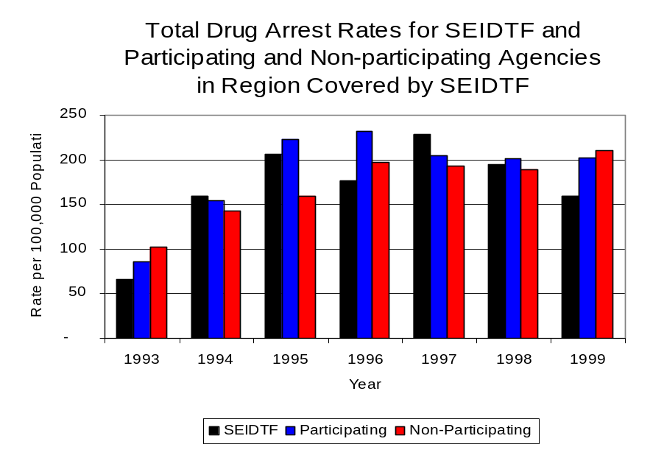
During the period analyzed, the drug arrest rate for cannabis and controlled substances, combined, in the region covered by SEIDTF more than doubled, from 95 arrests per 100,000 population in 1993 to 207 arrests per 100,000 population in 1999. Similarly, the drug arrest rate in the participating agencies more than doubled, from 86 to 203 as did the drug arrest rate for non-participating agencies, which more than doubled from 102 to 210 arrests per 100,000 population. The arrest rate for SEIDTF also more than doubled during that period, from 65 to 160 arrests per 100,000 population (Figure 5). Thus, the drug arrest rate tended to be slightly higher in the jurisdictions that did not participate in SEIDTF than in those jurisdictions that did participate in SEIDTF. Also, the drug arrest rate achieved by SEIDTF was relatively close to that experienced by both participating and non-participating agencies, meaning that the unit made almost as many arrests for violations of the Cannabis and Controlled Substances Act, with 12 officers, as did all of the respective participating and non-participating agencies, combined.
Source: ICJIA calculations using Illinois State Police, SEIDTF and U.S. Census Bureau data
Figure 5

Across the individual local law enforcement agencies in the region covered by SEIDTF, the number of cannabis and controlled substance arrests ranged from zero to 26. Of the 293 drug arrests made during 1999 in the eight-county region, seven agencies accounted for 60 percent of these drug arrests. Twenty-six agencies had fewer than 15 drug arrests reported in 1999 and are excluded from Figure 6. The Clark and Lawrence county sheriff’s offices and the Newton and Salem police departments each accounted for 9 percent of cannabis and controlled substance arrests, while the Marion, Marshall and Robinson police departments each accounted for 8 percent of cannabis and controlled substance arrests in the region (Figure 6). Of the nine agencies with the highest number of drug arrests in 1999, four participated in SEIDTF.

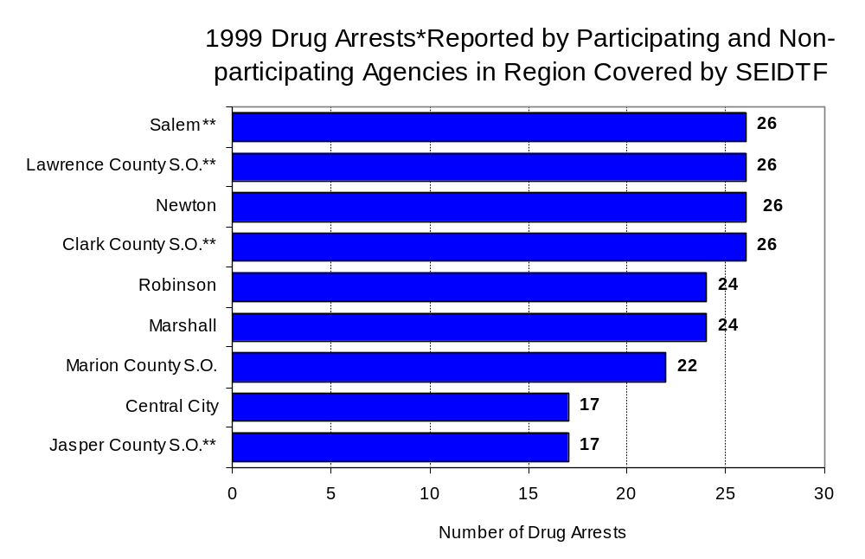
In addition to the dramatic difference in the number of drug arrests made, there are also differences in the types of drug law violation arrests across the agencies in the region. In 1999, violations of the Cannabis Control Act and the Drug Paraphernalia Control Act accounted for the majority of arrests across most individual agencies in the region covered by SEIDTF (Figure 7).
Source: Illinois State Police *Agencies reporting 15 or more drug arrests
**Agency does not participate in SEIDTF
Figure 6
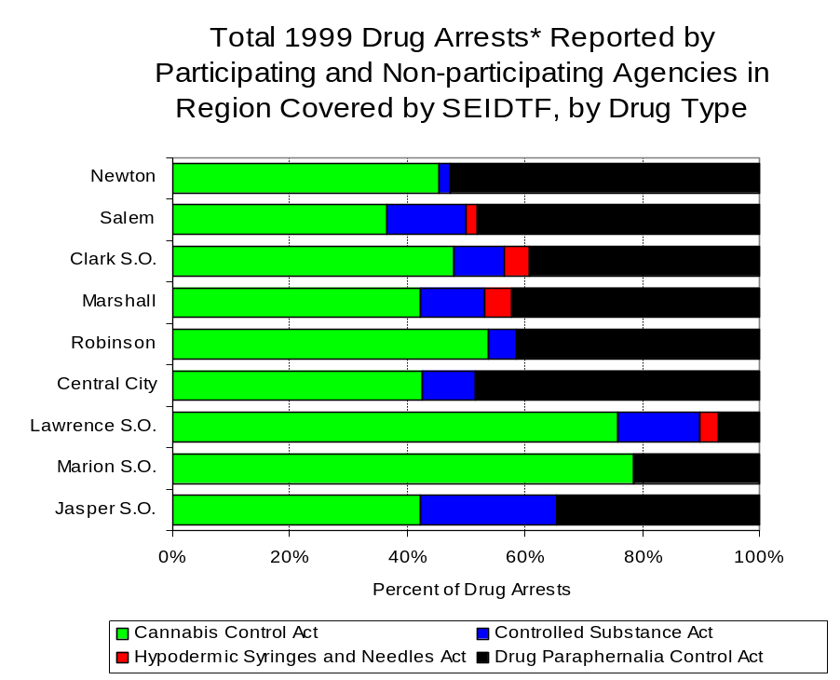
Source: Illinois State Police *Agencies reporting 25 or more drug arrests
Figure 7

Between 1993 and 1999, the number of combined cannabis and controlled substances arrests made by SEIDTF more than doubled, from 42 to 104 (Figure 8), with a period high of 149 arrests in 1997. Similar to drug arrests made by most local police departments in the region, violations of the Cannabis Control Act accounted for the majority of drug arrests made by SEIDTF throughout most of the period analyzed. During the period analyzed, the number of SEIDTF arrests for violations of the Cannabis Control Act increased 46 percent, from 35 to 51, while the arrests for violations of the Controlled Substances Act increased dramatically, from seven to 53 (Figure 8).

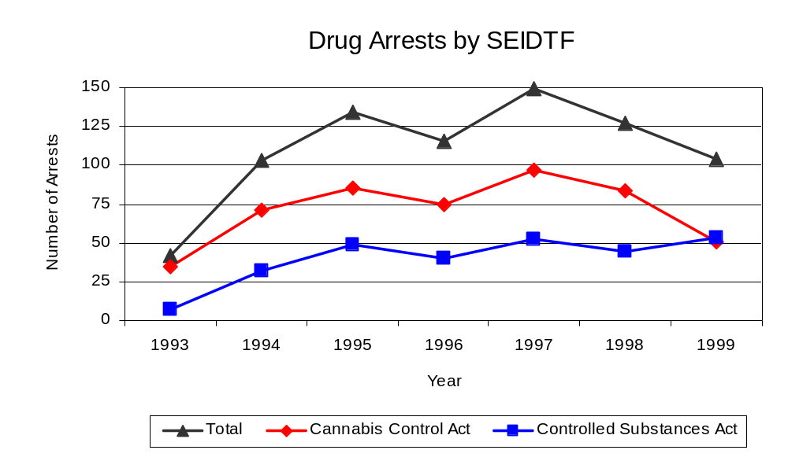
Between 1993 and 1999, the proportion of drug arrests accounted for by controlled substance violations increased for both participating and non-participating agencies. In 1999, arrests for controlled substances violations accounted for 22 percent of the drug arrests made in the eight-county region covered by SEIDTF, compared to 15 percent in 1993. For SEIDTF, the proportion of drug arrests accounted for by controlled substance violations tripled between 1993 and 1999. In 1999, 51 percent of the drug arrests made by SEIDTF were for violations of the Controlled Substances Act, compared to 17 percent in 1993. Thus, arrests by SEIDTF were more likely than arrests by either participating or non-participating agencies to involve violations of Illinois’ Controlled Substances Act, as opposed to the Cannabis Control Act. One interpretation of this pattern is that SEIDTF is more focused in who they are targeting and arresting than local departments, and are also getting a more serious drug law violator, since violations of the Controlled Substances Act are more likely to involve felony-level offenses.
Source: SEIDTF
Figure 8

The data presented below represent the percent of total drug arrests made in the eight-county region accounted for by SEIDTF. An upper and lower bound is shown in Figure 9 which accounts for whether or not the units numbers are counted as part of the UCR submissions made by local departments (which is unknown at this point). The upper bound indicates the percentage of arrests if none of the SEIDTF arrests are included in the local UCR submissions. The lower bound indicates the percentage if all of the SEIDTF arrests are included in the local UCR submissions. It is estimated that the proportion of all drug arrests in the eight-county region accounted for by SEIDTF was between 43 and 76 percent in 1993, and decreased to between 34 and 51 percent in 1999.

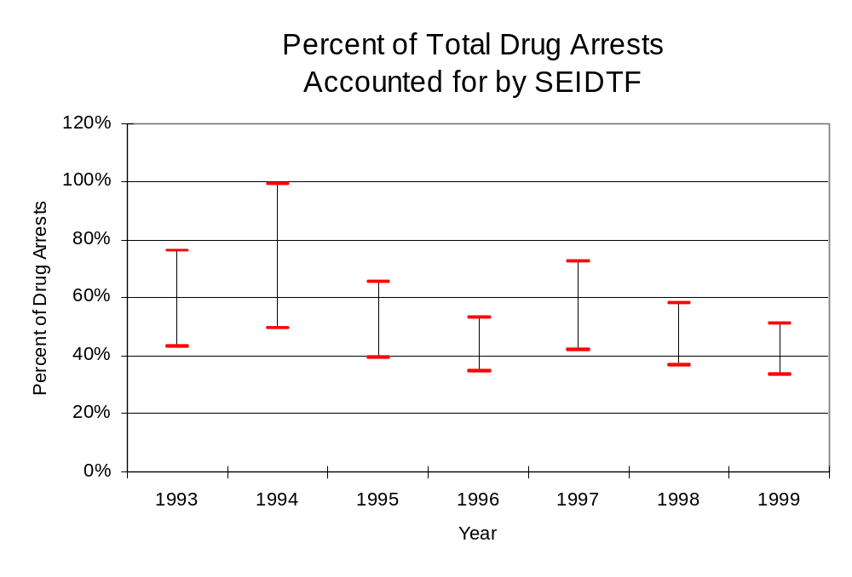
Source: ICJIA calculations using
Illinois State Police and SEIDTF data
Figure 9
The number of arrests for violations of Illinois’ Cannabis Control Act for Clark, Clay, Crawford, Cumberland, Fayette, Jasper, Lawrence and Marion counties totaled 307 in 1999, more than doubled the 140 arrests made for cannabis violations in 1993. Between 1993 and 1999, the proportion of all drug arrests accounted for by violations of the Cannabis Control Act in the eight-county region decreased 8 percent, decreasing from 85 percent to 78 percent. Agencies not participating in SEIDTF accounted for the largest portion (66 percent) of the total number of arrests for cannabis violations in 1999. SEIDTF reported a total of 51 arrests for cannabis violations in 1999, 49 percent of the unit's drug arrests.

During the period analyzed, the cannabis arrest rate for the region covered by SEIDTF more than doubled, from 100 arrests per 100,000 population in 1993 to 217 arrests per 100,000 population in 1999. The cannabis arrest rate in both the participating and non-participating agencies also doubled, from 79 to 160 arrests per 100,000 population and from 117 to 265 arrests per 100,000 population, respectively. The cannabis arrest rate for SEIDTF increased 43 percent, from 55 to 78 arrests per 100,000 population (Figure 10). Thus, the arrest rate for violations of the Cannabis Control Act was collectively higher in agencies not participating in SEIDTF than those agencies participating in SEIDTF.

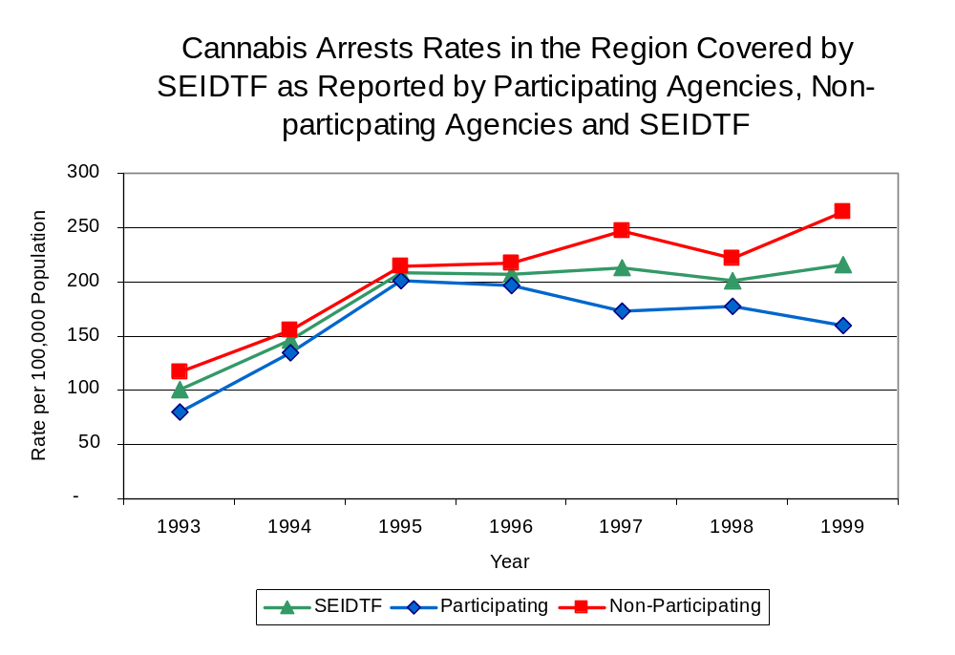
Source: ICJIA calculations using Illinois State Police and SEIDTF data
Figure 10
The data presented in Figure 11 represent the percent of cannabis arrests made in the eight-county region accounted for by SEIDTF. An upper and lower bound is shown which accounts for whether or not the unit’s numbers are counted as part of the UCR submissions made by local departments (which is unknown at this point). The upper bound indicates the percentage of arrests if none of the SEIDTF arrests are included in the local UCR submissions. The lower bound indicates the percentage if all of the SEIDTF arrests are included in the local UCR submissions. It is estimated that the proportion of cannabis arrests in the eight-county region accounted for by SEIDTF was between 41 and 69 percent in 1993, but decreased to between 33 and 49 percent in 1999.

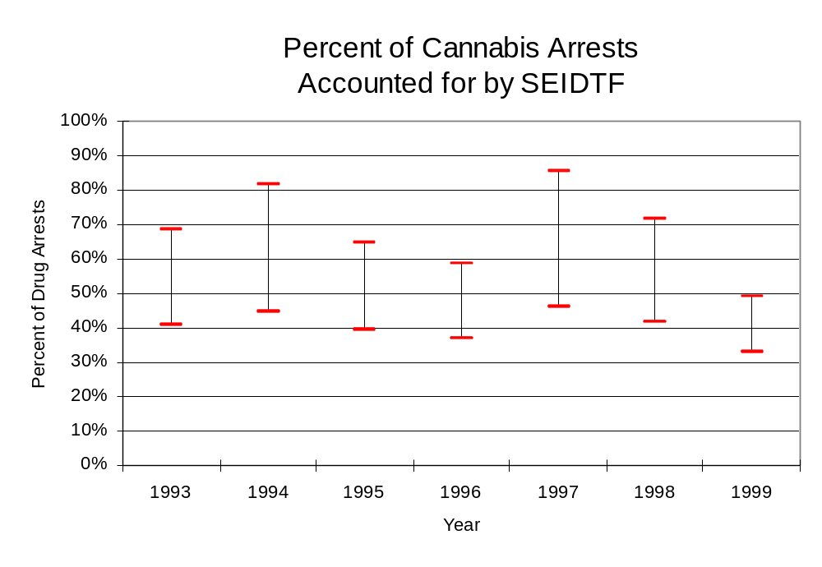
Source: ICJIA calculations using
Illinois State Police and SEIDTF data
Figure 11
In Clark, Clay, Crawford, Cumberland, Fayette, Jasper, Lawrence and Marion counties the number of arrests for violations of Illinois’ Controlled Substances Act more than tripled between 1993 and 1999, from 25 to 88. Between 1993 and 1999, the proportion of all drug arrests accounted for by violations of the Controlled Substances Act in the eight-county region increased from 15 percent to 22 percent. In 1999, SEIDTF reported 53 arrests for controlled substance violations, 51 percent of all drug arrests reported to the Authority by the unit.

Between 1993 and 1999, the arrest rate for controlled substances act violations for the region covered by SEIDTF also more than tripled, from 18 to 62 arrests per 100,000 population (Figure 12). The controlled substances arrest rate in the participating agencies increased nearly six-fold, from six to 43 arrests per 100,000 population, while the arrest rate in the non-participating agencies more than doubled, from 28 to 78 arrests per 100,000 population. The controlled substances arrest rate for SEIDTF increased more than six-fold, from 11 to 81 arrests per 100,000 population (Figure 12). Thus, the arrest rate for SEIDTF was slightly higher than the rate for those agencies not participating in SEIDTF, but nearly double the rate of all the participating agencies combined.

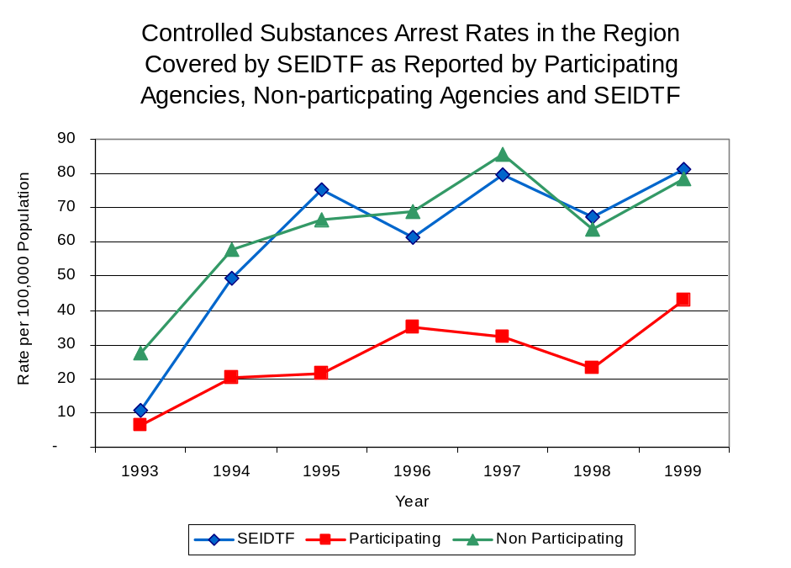
The data presented in Figure 13 represent the percent of controlled substances arrests made in the eight-county region accounted for by SEIDTF. Unlike the data presented in Figures 9 and 11, the data for SEIDTF controlled substances arrests appear to have been included as part of the UCR submissions made by local departments. It is estimated that the proportion of controlled substances arrests in the eight-county region accounted for by SEIDTF remained relatively stable during the period analyzed, accounting from between 64 and 65 percent.
Source: ICJIA calculations using
Illinois State Police and SEIDTF data
Figure 12
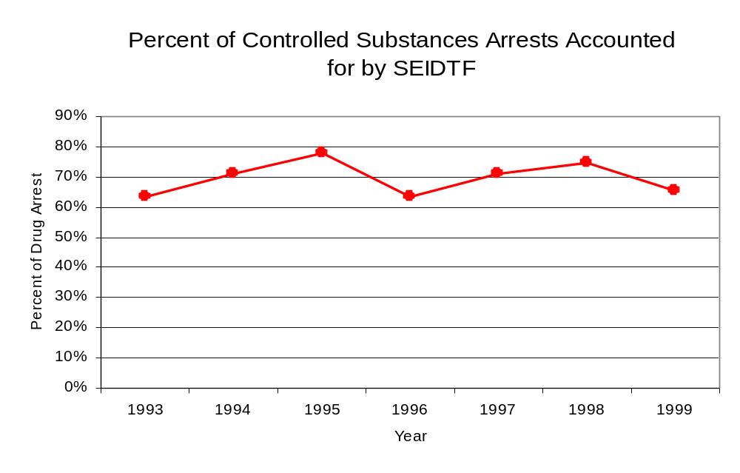
Source: ICJIA calculations using
Illinois State Police and SEIDTF data
Figure 13

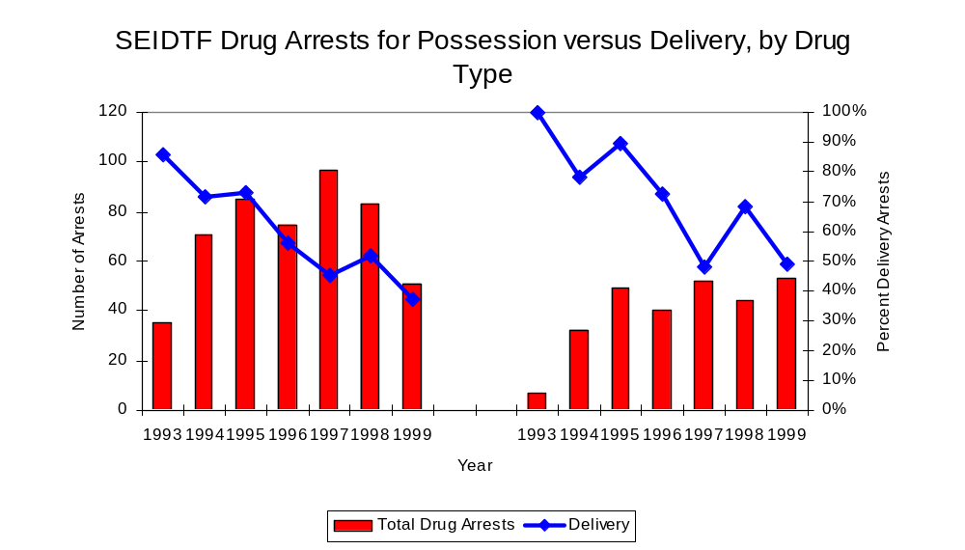
Although the majority of all drug arrests reported by SEIDTF during the period between 1993 and 1999 were for drug delivery, that proportion decreased during the period examined. Arrests for drug delivery accounted for 62 percent of all drug arrests made by SEIDTF between 1993 and 1999; however, that proportion decreased significantly, from 88 percent in 1993 to 43 percent in 1999. When cannabis and controlled substance arrests were examined separately during the period analyzed, similar trends were observed. While arrests for delivery of controlled substances accounted for 72 percent of the total number of arrests made for violations of the Controlled Substances Act, during the period analyzed, that proportion decreased from 100 percent in 1993 to 49 percent in 1999. Similarly, while arrests for the delivery of cannabis accounted for 60 percent of all arrests for violations of the Cannabis Control Act during the same period, the proportion of arrests for delivery decreased from 86 percent to 37 percent.
Figure 14
Source: ICJIA calculations using SEIDTF data
Cannabis Control Act

Controlled Substances Act

IV. Trends in Drug Seizures

Drugs seized by law enforcement agencies are another indicator of the extent and nature of illegal drug trade in a jurisdiction. When illegal drugs are seized by law enforcement agencies, all or a portion of the total amount seized is submitted to a crime lab for analysis. Most agencies submit drugs to one of the Illinois State Police crime labs. These labs record the quantity of drugs submitted from each county. This section discusses trends in the quantities of illegal drugs seized and submitted to the Illinois State Police from local law enforcement agencies in Clark, Clay, Crawford, Cumberland, Fayette, Jasper, Lawrence and Marion counties as well as the quantities of drugs seized by SEIDTF. It is important to note, however, that while SEIDTF data report the total quantities of drugs actually seized, local agency data only represent the quantities of seized drugs that are submitted to the Illinois State Police for analysis. County-level cannabis, cocaine and methamphetamine seizure rates for Illinois' 102 counties are provided in maps located in the Appendix of this report.

As in most Illinois jurisdictions, cannabis accounts for the majority of illegal drugs seized in the eight-county region covered by SEIDTF. The quantity of cannabis seized and submitted by law enforcement agencies in Clark, Clay, Crawford, Cumberland, Fayette, Jasper, Lawrence and Marion counties decreased 17 percent, from 12,018 grams in 1993 to 10,006 grams in 1999, with. The quantity of cannabis seized by SEIDTF decreased 68 percent between 1993 and 1999, from 13,297 grams to 4,276 grams despite jumping to more than 83,000 grams seized in 1995 (Figure 15). In 1999, SEIDTF's cannabis seizure rate of 6,561 grams per 100,000 population was lower than the statewide cannabis seizure rate of 31,533 grams per 100,000 population, and lower than the seizure rate of 7,057 grams per 100,000 population in the eight-county region covered by SEIDTF (Map 2).

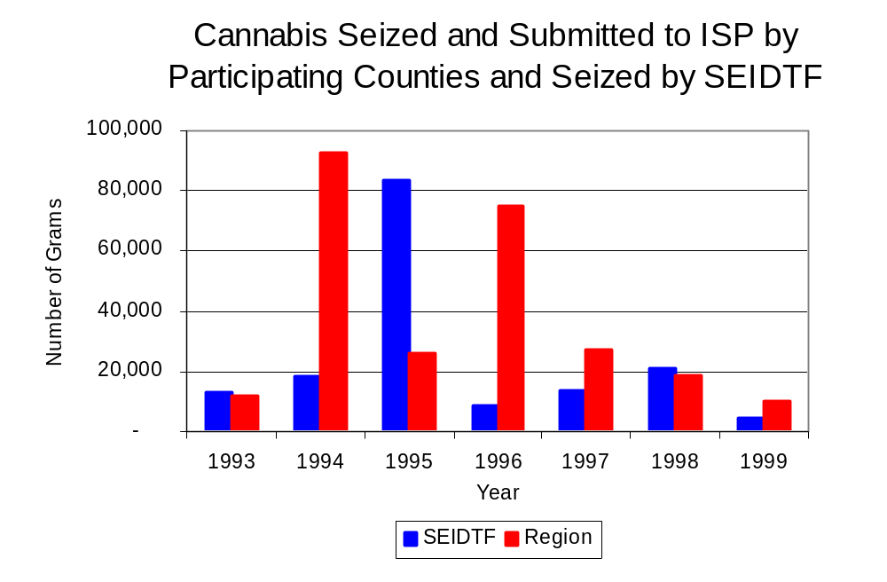
Source: Illinois State Police and SEIDTF
Figure 15

Between 1993 and 1999, a combination of crack and powder cocaine has accounted for a small proportion of drugs seized in the eight-county region covered by SEIDTF. However, the quantity of cocaine seized and submitted by law enforcement agencies Clark, Clay, Crawford, Cumberland, Fayette, Jasper, Lawrence and Marion counties increased 49 percent, from 356 grams in 1993 to 531 grams in 1999. Between 1993 and 1999, the quantity of cocaine seized by SEIDTF decreased 53 percent, from 39 grams to 18 grams.

The proportion of all cocaine seized by SEIDTF accounted for by powder cocaine remained relatively stable between 1993 and 1999, whereas local seizures revealed a bit more variation. Powder cocaine accounted for the largest proportion of total cocaine seizures for those agencies not participating in SEIDTF in nearly every year examined. However, the proportion decreased from 58 percent in 1993 to 9 percent in 1999 (Figure 16). In 1999, SEIDTF's cocaine seizure rate of 28 grams per 100,000 population was significantly lower than the cocaine seizure rate of 375 grams per 100,000 population in the eight-county region covered by SEIDTF, but dramatically less than the statewide cocaine seizure rate of 15,735 grams per 100,000 population.
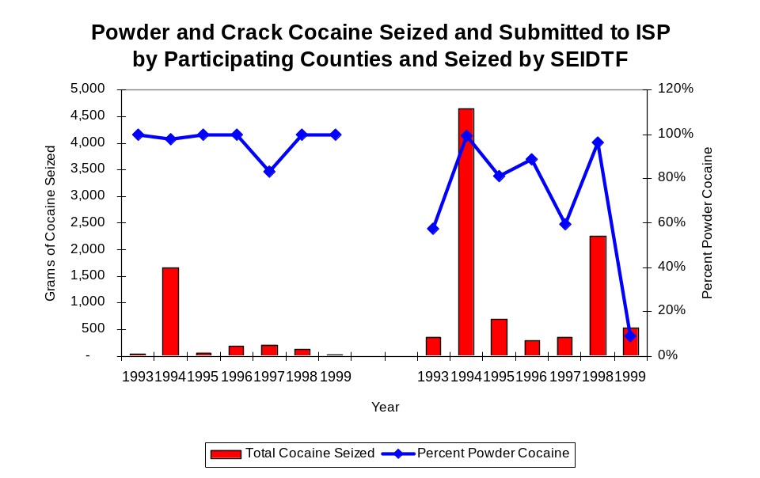
Figure 16
Source: Illinois State Police and SEIDTF
SEIDTF
Region

The total quantity of illegal drugs seized and submitted by law enforcement agencies in Clark, Clay, Crawford, Cumberland, Fayette, Jasper, Lawrence and Marion counties decreased between 1993 and 1999, from 12,401 grams to 11,480 grams, with a high of 97,206 grams seized in 1994. On the other hand, the total quantity of illegal drugs seized by SEIDTF increased, from 13,903 grams in 1993 to 15,553 grams in 1999.

During the period, methamphetamine seizures accounted for a relatively small proportion of total drugs seized by SEIDTF and the eight-county region covered by SEIDTF. Between 1994 and 1999, the quantity of methamphetamine seized by law enforcement agencies in the region where SEIDTF operates increased nearly ten-fold, from 69 grams to 873 grams. Although SEIDTF reported no methamphetamine seizures between 1994 and 1995, the quantity of methamphetamine seized by SEIDTF increased from 40 grams in 1996 to 921 grams in 1999. In 1999, SEIDTF had a methamphetamine seizure rate of 1,413 grams per 100,000 population, more than double the rate of 615 grams per 100,000 population in the eight-county region covered by SEIDTF and significantly higher than the statewide seizure rate of 98 grams per 100,000 population (Map 4).

Trends in Prosecutions for Drug Offenses and All Felonies

Although Illinois has one of the best court reporting systems in the country, the Administrative Office of the Illinois Court only collects information regarding the aggregate number of court filings. Currently, there are no statewide data available on court filings by offense type. The Administrative Office of the Illinois Courts reports data on felony criminal court cases. After screening a case and deciding it warrants further action, the state’s attorney must file formal charges in court. Felony cases can be punished by a probation term up to four years and incarceration for more than one year.

Between 1989 and 1999, the number of felony filings in the eight-county region covered by SEIDTF increased 41 percent, from 726 to 1,027 (Figure 17).

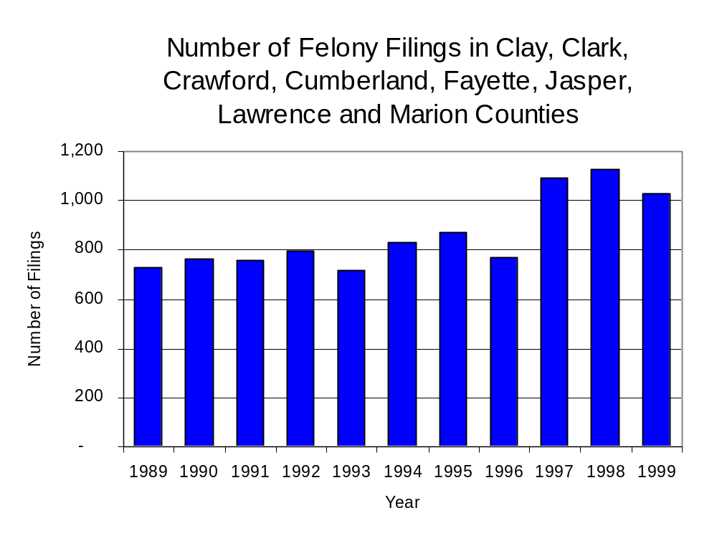
Figure 17
Source: Administrative Office of the Illinois Courts

Between 1992 and 1999, there were a total of 800 drug prosecutions initiated as a result of SEIDTF arrests in Clark, Clay, Crawford, Cumberland, Fayette, Jasper, Lawrence and Marion counties. Thirty-five percent of SEIDTF drug offender prosecutions during this period were for violations of the Controlled Substances Act, while 65 percent were for violations of the Cannabis Control Act. During this time, the number of SEIDTF drug arrests more than doubled, from 44 arrests in 1992 to 104 arrests in 1999 (Figure 18). Between 1992 and 1999, approximately 98 percent of drug arrests by SEIDTF resulted in felony prosecution. No prosecutions were reported between 1989 and 1991. In some years, the proportion of arrests resulting in a prosecution exceeded 100 percent. This may be due to charges, rather than defendants, being reported by the unit. Also, some offenders have charges filed, and a subsequent warrant issued, without an arrest taking place.
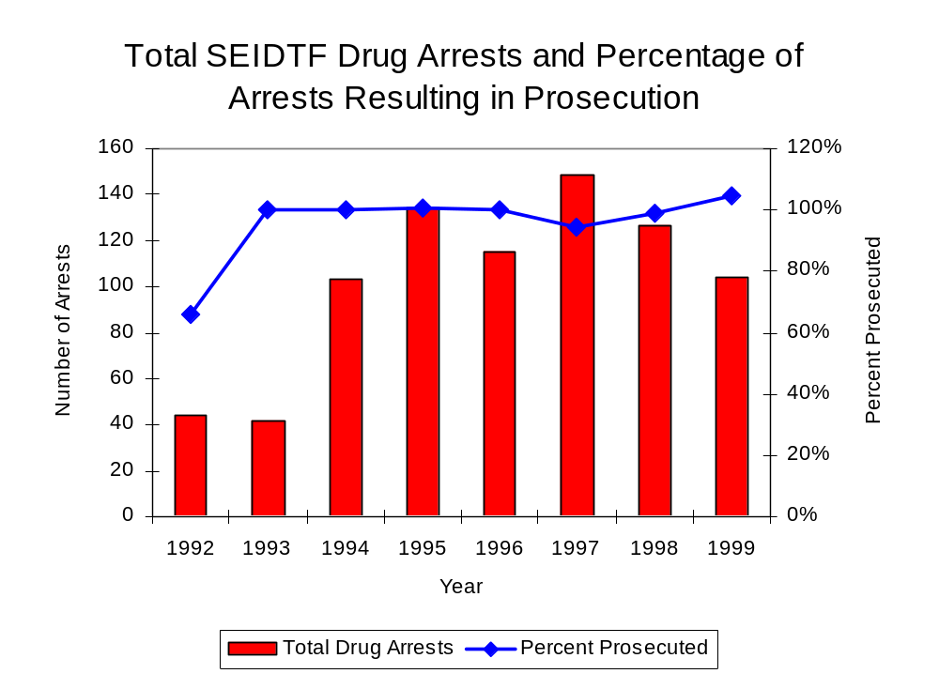
Figure 18
Source: SEIDTF

Between 1992 and 1999, 76 percent (609) of the 800 drug offenders who were prosecuted as a result of SEIDTF activity were convicted. Convictions for controlled substances accounted for 29 percent of all SEIDTF initiated convictions during the period analyzed, while convictions for cannabis accounted for 71 percent.

VI. Trends in Percent of Convicted Drug Offenders Sentenced to Prison

Anyone convicted of a felony in Illinois can be sentenced either to prison or probation, or receive conditional discharge. A number of factors influence the type and length of sentence imposed on convicted felons, including the severity of the crime, the offender’s criminal and social history, safety of the community and legislation affecting certain types of offenses. For some types of convictions, a sentence to prison is required by state statute.

Between 1989 and 1999, the number of offenders convicted of a felony and sentenced in the eight-county region covered by SEIDTF increased 37 percent, from 474 to 649. The number of convicted felons sentenced to the Illinois Department of Corrections (IDOC) increased 49 percent between 1989 and 1999, from 146 to 218, which caused the proportion of felons sentenced to IDOC to increase during the same period, from 31 percent to 34 percent of total felony sentences. In 1999, 396 probation sentences were imposed on convicted felons, which was a 24 percent increase in the number of probation sentences in 1989 (Figure 19). However, the proportion of felons sentenced to probation decreased from 67 percent in 1989 to 61 percent in 1999. Sentences other than prison or probation account for the remaining 5 percent of felony sentences imposed in 1999.
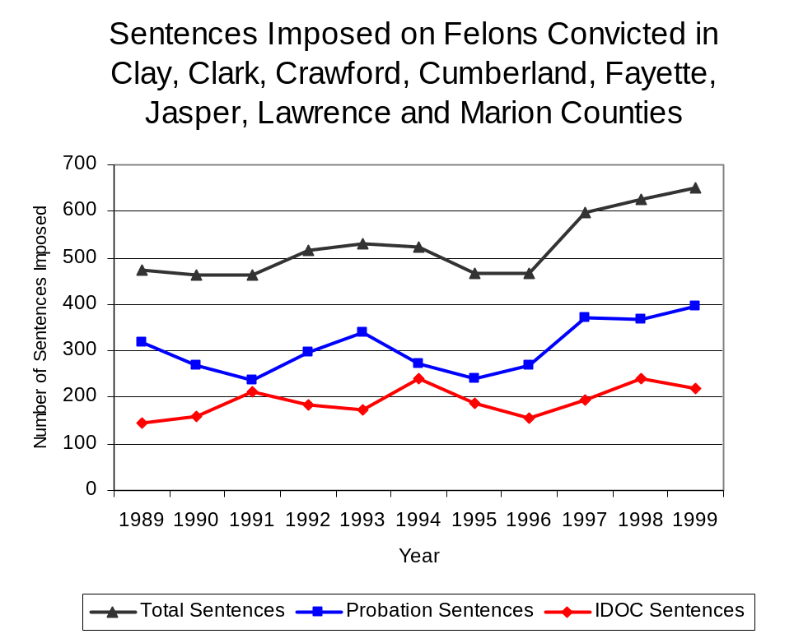
Figure 19
Source: Administrative Office of the Illinois Courts

Between 1989 and 1999, the number of SEIDTF drug offenders convicted and sentenced increased from 58 to 75, with a high of 119 convicted and sentenced in 1996. During the period analyzed, the number of convicted SEIDTF drug offenders sentenced to probation increased from 32 in 1989 to 38 in 1999, although in 1996, the number of convicted SEIDTF drug offenders sentenced to probation reached a high of 69 sentences. Similarly, the number of convicted SEIDTF drug offenders sentenced to jail increased from nine to 21. The number of drug offenders sentenced to prison decreased slightly during the period analyzed, from 17 to 16, with a high of 28 sentenced to prison in 1995 (Figure 20). In 1999, among those SEIDTF drug offenders convicted and sentenced, probation sentences accounted for the largest proportion (51 percent), followed by jail sentences (28 percent) and prison sentences (21 percent).
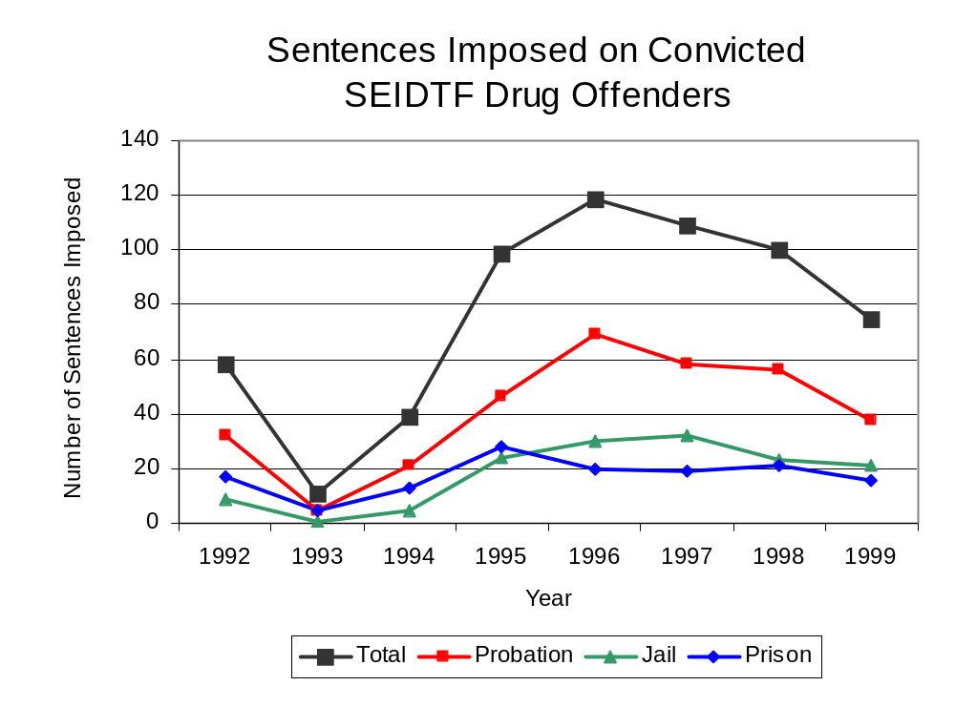
Figure 20
Source: SEIDTF

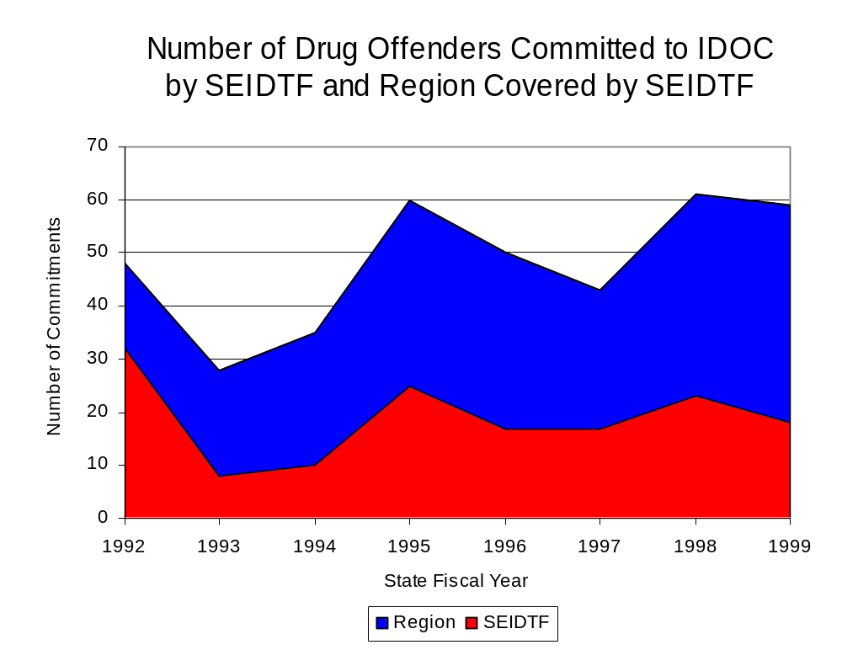
Between state fiscal years 1992 and 1999, the number of new court commitments to IDOC’s Adult Division for drug offenses from the eight-county region covered by SEIDTF increased 23 percent, from 48 to 59. However, the number of drug offender admissions by SEIDTF decreased from 32 to 18 between 1989 and 1999 (Figure 21). Between state fiscal years 1992 and 1999, prison sentences resulting from SEIDTF cases mirrored prison-sentence trends for the eight-county region and accounted for 40 percent of all drug-law violators sentenced to prison from the region. In 1999, SEIDTF accounted for 31 percent of all drug offenders committed to the Illinois Department of Corrections from the eight-county region covered by SEIDTF, compared to 67 percent in 1992.
Figure 21
Source: Illinois Department of Corrections and SEIDTF

During the period analyzed, drug offenders accounted for an increasing proportion of adults convicted and sentenced to prison from Clark, Clay, Crawford, Cumberland, Fayette, Jasper, Lawrence and Marion counties. In 1989, drug offenses accounted for 15 percent of all commitments to IDOC, compared to 28 percent in 1999 (Figure 22).
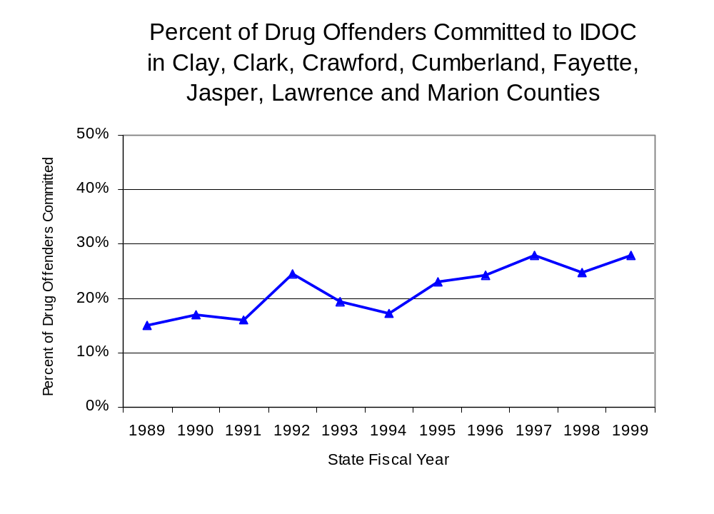
Figure 22
Source: Illinois Department of Corrections

Penalties for drug offenses were also examined between 1993 and 1999. Class 4 felonies accounted for the largest proportion (44 percent) of sentences to IDOC for drug offenses, followed by Class 1 felonies (19 percent), Class 3 felony sentences (18 percent), Class 2 felonies (13 percent) and Class X felonies (6 percent). Between 1993 and 1999, the number of Class 4 felony offenses increased from 6 to 35, Class 1 felony sentences increased from ten to eight, Class X felony sentences increased from zero to three, and the number of Class 3 felonies increased from eight to 11. However, the number of Class 2 felonies decreased during the period analyzed, from seven to two (Figure 23).

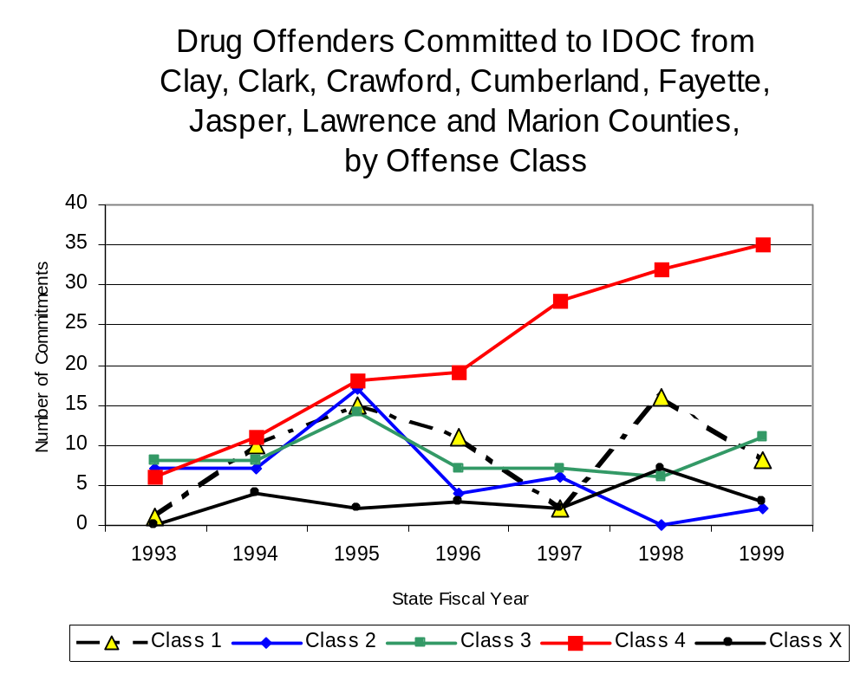
Source: Illinois Department of Corrections
Figure 23

Similar to the increase in Class 4 felony sentences to IDOC between 1993 and 1999, the mean sentence length for Class 4 felonies also increased slightly from 1.67 to 1.73 years during the period examined. The mean sentence length for Class X felonies increased from 0 to 6.33 years and the mean sentence for a Class 3 felony increased from 2.84 to 3.14 years. However, Class 1 sentence lengths decreased from 9 to 6.63, while the mean sentence length for Class 2 felonies remained unchanged at 4 years.

Based on data collected from the 2000 Illinois Adult Probation Outcome Study, just over 10 percent (11.5 percent) of all adults discharged from probation in Clark, Clay, Crawford, Fayette, Jasper, Lawrence and Marion counties combined during the study period (November 2000) were convicted of drug-law violations. Of these drug-law violators discharged from probation in the region, almost three-quarters (72.7 percent) had been convicted of a felony drug offense. In addition, more than three-quarters (81.8 percent) of these drug-law violators were ordered to participate in some form of treatment, and each was ordered to pay, on average, $1,358 in the form of supervision fees, court costs and fines.

VII. Trends in Drug Treatment Admissions in SEIDTF Region by Drug Type

In addition to considering indicators of the extent and nature of drug abuse as reported through the criminal justice system (for example, arrests and prison sentences), there are indicators of substance abuse available from other Illinois social service agencies. Overseeing and supporting treatment for substance users, whether they are referred from the criminal justice system or elsewhere, is the responsibility of the Illinois Department of Human Services’ Office of Alcoholism and Substance Abuse (OASA). It is important to note, however, that while OASA data represent the majority of the overall demand for substance abuse treatment in the state, some private programs provide treatment services to a smaller but significant number of clients who may not be included in the state’s reporting system.

In state fiscal year 1999, OASA reported 1,587 admissions for alcohol or drug abuse treatment from Clark, Clay, Crawford, Cumberland, Fayette, Jasper, Lawrence and Marion counties, 63 percent more than the 972 admissions in 1989 (Figure 24). Among the 1,587 admissions to substance abuse treatment in state fiscal year 1999, 65 percent (1,031) reported alcohol as their primary substance of abuse, while abuse of illicit substances accounted for 32 percent (513), and 2 percent reported no primary substance of abuse.

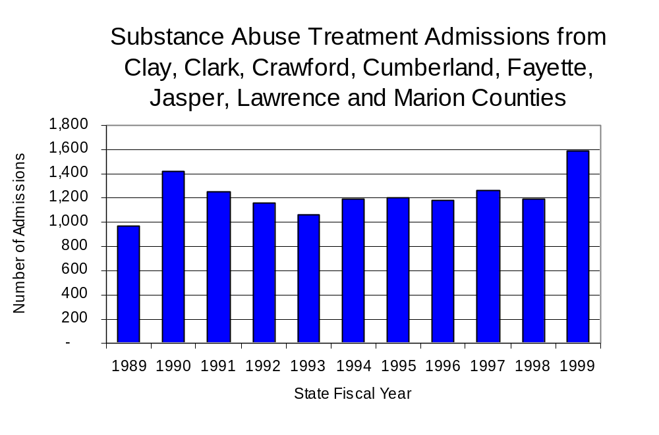
Figure 24
Source: Illinois Department of Human Services’
Office of Alcoholism and Substance Abuse
While drug treatment admissions can be considered a measure of the demand placed on a specific component of the human services system within Illinois, the extent and nature of drug treatment admissions could also be indicative of the substance abuse problem within a particular region. In some respects, the characteristics of those admitted to drug treatment can be considered a profile of the most serious drug abusers in the community, since admission to treatment requires a documented, formal assessment of a drug problem and a level of substance abuse warranting treatment. By comparing the types of drugs of abuse reported by those admitted to substance abuse treatment with the types of drugs involved in law enforcement agency arrests, one can get a sense of the degree to which arrests reflect the drugs which are most problematic within a community.

In the following analyses, the percent of arrests accounted for by drugs classified under Illinois’ Controlled Substances Act (primarily cocaine, heroin, and methamphetamine) versus the Cannabis Control Act (marijuana) across the participating agencies combined, non-participating agencies combined and SEIDTF are compared to the proportion of drug treatment admissions accounted for by these groups of substances. From these comparisons, a number of general conclusions can be made. First, the proportion of arrests made by SEIDTF accounted for by drugs other than marijuana (Controlled Substances Act offenses) was very close to the proportion of drug treatment admissions from the covered region accounted for by these substances. Thus, there is considerable convergence between the drugs involved in SEIDTF arrests and treatment admissions. On the other hand, the majority of arrests by local police departments (including those participating in SEIDTF and non-participating agencies) were for cannabis offenses. Thus, while local arrests may reflect the most widely available and used drug in the region, they tend not to involve the substances considered to be most serious (i.e., felony versus misdemeanor) nor the substances individuals are seeking and receiving treatment for (Figure 25).

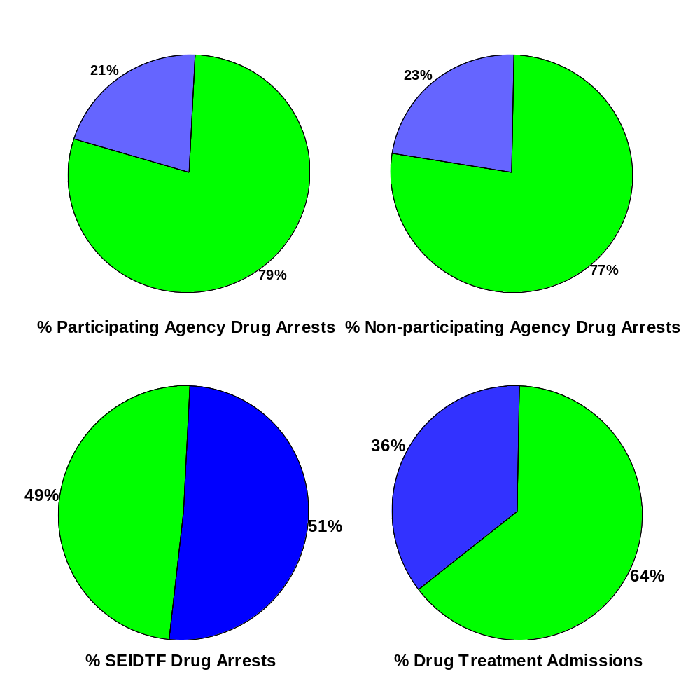
Source: Illinois Department of Human Service’s Office of Alcoholism and Substance Abuse, Illinois State Police and SEIDTF
Cannabis
Controlled Substances
Figure 25
Comparison of Drug Arrests by SEIDTF and Participating and Non-participating Agencies vs. Drug Abuse Treatment Admissions in Clay, Clark, Crawford, Cumberland, Fayette, Jasper, Lawrence and Marion Counties, 1999

VIII. Trends in Drug Exposed Births

Illinois continues to experience the effects of prenatal substance abuse. In Illinois, if a baby is born and thought to have been exposed to illegal substances or alcohol, either through observation by physicians or toxicology tests, the case is reported to the Illinois Department of Children and Family Services. These cases are then investigated by DCFS to verify the child’s prenatal exposure to either alcohol or illegal substances. Between state fiscal years 1989 and 1999, nearly one-half (50) of Illinois’ 102 counties reported at least one case of a substance-affected infant.

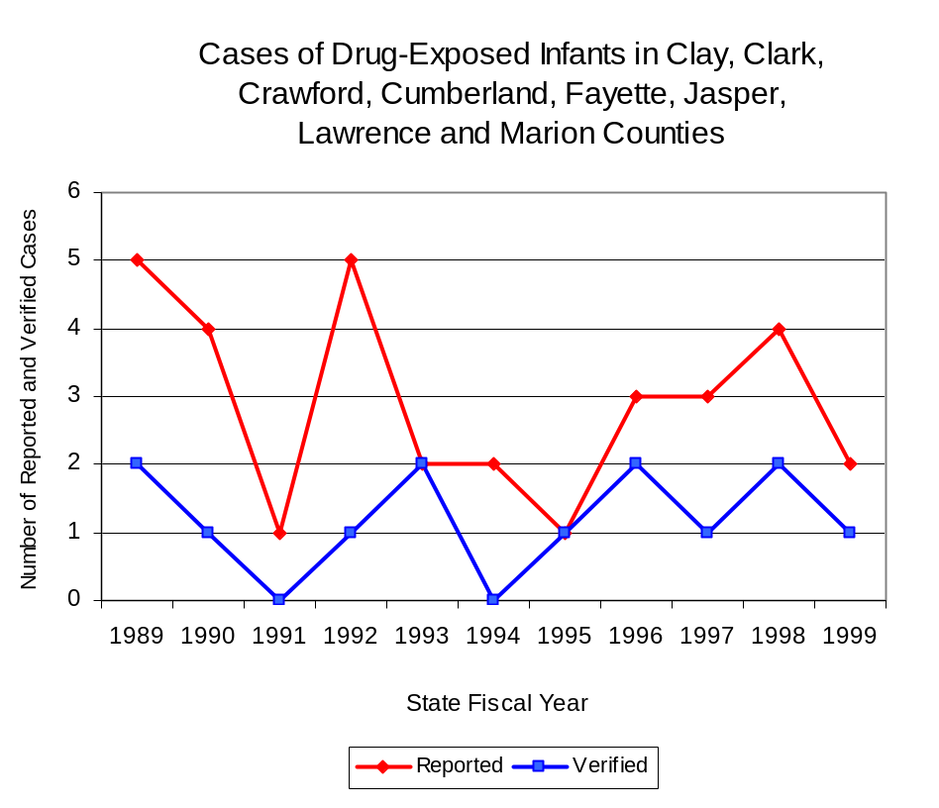
Between state fiscal years 1989 and 1999, the number of drug-exposed infant cases reported in the eight-county region covered by SEIDTF decreased from five to two reported cases. Between state fiscal years 1989 and 1999, 13 cases, or 41 percent of all cases reported, were verified as involving prenatal drug use by a DCFS investigation. Mirroring the trend of reported cases, verified cases of drug-exposed infants in the SEIDTF region also decreased between 1989 and 1999 from two to one (Figure 26).
Source: Department of Children and Family Services
Figure 26

IX. Summary of Drug Situation

Although the distribution of illegal drugs is difficult to measure precisely, data obtained from criminal justice sources can be helpful in estimating drug availability. Information from a recent survey of Illinois drug enforcement units, as well as the most up-to-date data available on drug price, are presented as indicators of the drug supply in Illinois.

In 1995, 1996 and 1998, the Authority conducted a survey of each MEG and task force in Illinois to gauge the perceived availability of drugs in the areas they cover. Questions were asked concerning the availability of specific drugs, and results were analyzed by region of the state. MEGs and task forces are classified as being either urban, rural or mixed urban/rural based upon the classification of the county(s) that each unit covers, and, for purposes of this report, are compared to the average of similar units.

According to SEIDTF survey responses, cannabis, cocaine and crack continued to be the most visible drugs on the street and were all reported to be “readily available” across all regions analyzed. While perceived availability of cannabis and cocaine remained relatively unchanged in the eight-county region covered by SEIDTF, the perceived availability of crack, heroin, PCP and methamphetamine increased slightly since the 1996 survey, while LSD decreased in the region covered by SEIDTF. Methamphetamines were reported as moderately available across Illinois but available to a greater degree in the region covered by SEIDTF and by all MEGs and task forces in mostly rural regions. The perceived availability of all drugs, excluding methamphetamine, tended to be greater across Illinois and in other mostly rural regions than in the region covered by SEIDTF (Figure 27).
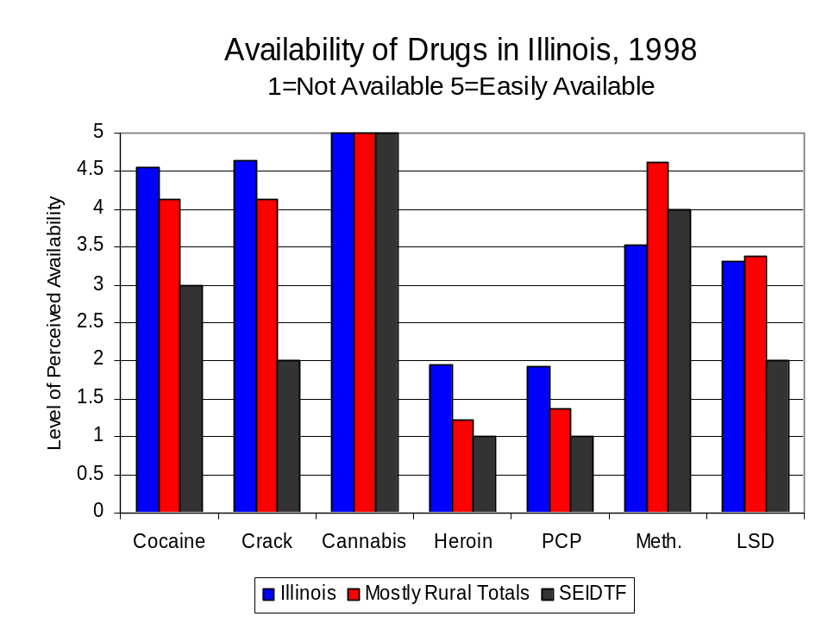
Figure 27
Source: Authority Survey of Illinois MEGs and task forces
Another market indicator that can be used to assess availability is drug price. Lower prices tend to suggest a sufficient supply to meet demand, while increasing prices indicate decreased availability.

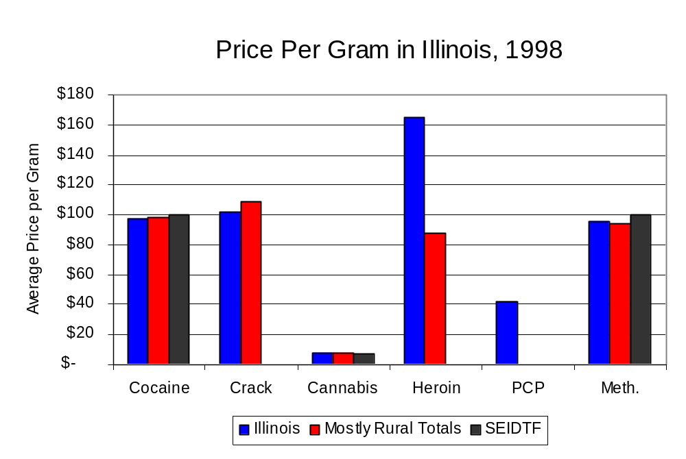
Based on a statewide survey of MEG and task force units, the average price of cocaine, crack and cannabis appear to be relatively stable across all regions surveyed in 1998, while prices for heroin appear to vary somewhat across Illinois. The average price of cocaine in the region covered by SEIDTF remained the same between 1996 and 1998, while it increased in the other mostly rural regions. The 1998 average price of cocaine reported by SEIDTF was $100 per gram, compared to $98 per gram across Illinois and $98 per gram reported by all MEGs and task forces in other mostly rural regions (Figure 28). On the other hand, the average price of Methamphetamine in the region covered by SEIDTF was reported as $100 per gram, higher than the price of $96 per gram across Illinois and the price of $94 per gram reported by all other MEGs and task forces in mostly rural regions. In 1998, the average price of cannabis was reported as approximately $7 per gram in the SEIDTF region, $8 per gram in mostly rural regions and $8 per gram across Illinois.
Figure 28
Source: Authority Survey of Illinois MEGs and task forces

X. Appendices
1999 Percent of Illinois'
County-level Population Covered by an Authority-funded Multi-jurisdictional Enforcement Group or Task Force
Map 1
* Shaded counties indicate that at least one law enforcement agency within the county participates in a MEG or task force
Percent of County Population Covered by MEG or Task Force

1999 Illinois
Cannabis
Seizure Rates, by County
Map 2
Cannabis Seizure Rate
(rate per 100,000 population)
1999 Illinois
Cocaine
Seizure Rates, by County
Map 3
Cocaine Seizure Rate
(rate per 100,000 population)
1999 Illinois Methamphetamine
Seizure Rates, by County
Map 4
Methamphetamine Seizure Rate
(rate per 100,000 population)

Bibliography

Administrative Office of the Illinois Courts, Annual Report to the Supreme Court of Illinois.
1989 through 1999 reports, Springfield, Illinois.

Administrative Office of the Illinois Courts’ Probation Division, Statewide Probation Data
Report. 1989 through 1999 reports, Springfield, Illinois.

Illinois Department of Human Services’ Office of Alcoholism and Substance Abuse. Data
provided for state fiscal years 1989 through 1999, Springfield, Illinois.

Illinois Department of Children and Family Services, Child Abuse/Neglect Statistics Report,
1989 through 1999 reports, Springfield, Illinois.

Illinois Department of Corrections. Data provided for fiscal years 1989 through 1999,
Springfield, Illinois.

Illinois State Police, Crime in Illinois. 1993 through 1999 reports, Springfield, Illinois.

Illinois State Police, Drug Statistics Report. Monthly reports, January 1989 through
December 1999, Springfield, Illinois.

Southeastern Illinois Drug Task Force. Monthly reports, January 1989 through December
1999, Effingham, Illinois.

U.S. Bureau of the Census.


George H. Ryan, Governor
Peter B. Bensinger, Chairman
Candice M. Kane, Executive Director

The Centralia Police Department, which is located in Marion County, does not participate in the Southeastern Illinois Drug Task Force Unit. Therefore, to accurately reflect the rates calculated for this profile, the population of Centralia has been excluded. in addition, then number of arrests used for non-participating agencies and for the region as a whole excludes the number of arrests reported by the Centralia Police Department.

